PT 5210 VariTime Digital Sync Generator

and

PT8603 SDI Test signal Generator

Supplement to: PT 5210 Reference: Manual no. 9499 491 02211

The supplement describes the modifications made to the standard instrument.
This supplement also covers the update PROM kit: 9449 900 22001

Feature: Moving text in the SDI signals for revealing “frozen” transmission lines or processes.

PT 5210
Software in the PT5210 has been modified to allow for moving text feature in PT8603
The text menu contains now “Text ON/OFF” only. The remote interface commands are unchanged.
Master software version is 3.7.

Position: | Code number | Checksum
V403 | 4008 002 08031 | A35F
For positioning of the processor please refer to photo below:
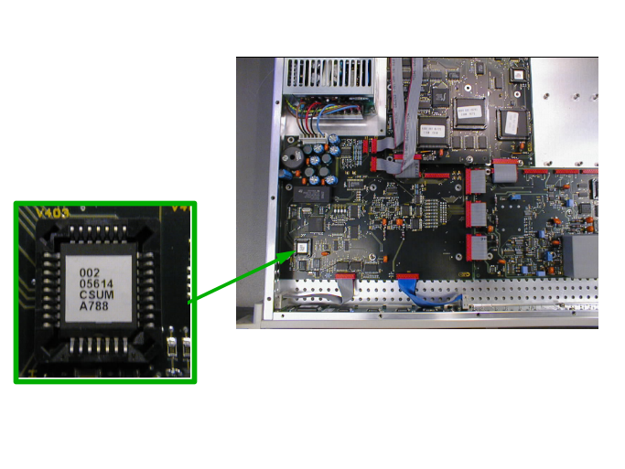

PT 8603
- Text, if ON, moves vertically, and scroll from line 48 to 100 (first line in black backgound).
- The text scrolls up and down slowly at a rate of 1 line per field.
- Text is placed in the blue and red bars in the colorbar
- Text may be ON or OFF.
Software version is 3.9
New PROM installed.

Position: | Code number | Checksum
V53 | 4008 002 08041 | 5E9D

For positioning of the processor please refer to drawing below:
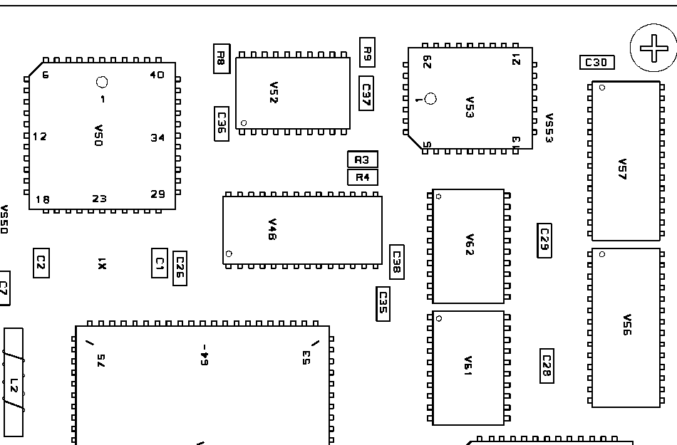
V53

